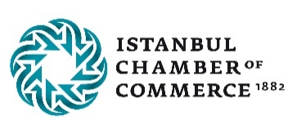

SUPPLIER DAYS 2022

Since 1990, the Turkish Suppliers Exchange (TSPX) has been an industrial intermediary organization within the Istanbul Chamber of Commerce with nearly 3,500 members. It was established in cooperation with UNIDO (United Nations Industrial Development Organization) and now has 32 years of experience both domestically and internationally. In short, TSPX is a technical information resource for main contractors and buyers.
TSPX is also a promotion office for the members, primarily for small and medium enterprises (SMEs) who want to expand their business. Advantages of TSPX:
- An effective way to establish contacts between potential business partners
- The opportunity to meet with qualified Turkish suppliers.
- All the requirements of main contractors or buyers are scanned in the database and the results are evaluated.
- suitable suppliers are identified with the help of the database
- tailor-made meetings
- All the information and the services are free of charge
TSPX organizes the "Supplier Days" event exclusively for the main contractor and its purchasing department. This is an effective way to establish close contacts between potential business partners. All main contractor requirements for parts, components, modules and various operations are evaluated by TSPX experts, and eligible suppliers are identified using the database. In the attachment you will find more information about the supplier days.
We have successfully organized exclusive events for Bosch Rexroth (Germany), Festo (Germany), Schneider Electric (France), Harman (Denmark), Hitachi (Japan), Girbau (Spain), Continental(Germany), Schaeffler (Germany), Munters(Sweden), Toyota(Japan).
We would like to organize an exclusive, customized B2B event (face to face / online) for your company in 2022.
We look forward to your suggestion for suitable dates.
If you have any further questions, please contact us.

Sincerely yours,

